Общие задания:
- with open("numbers.txt", "w", encoding="utf-8") as file:
for i in range(1, 257):
file.write(str(i))
if i < 256:
file.write(", ")
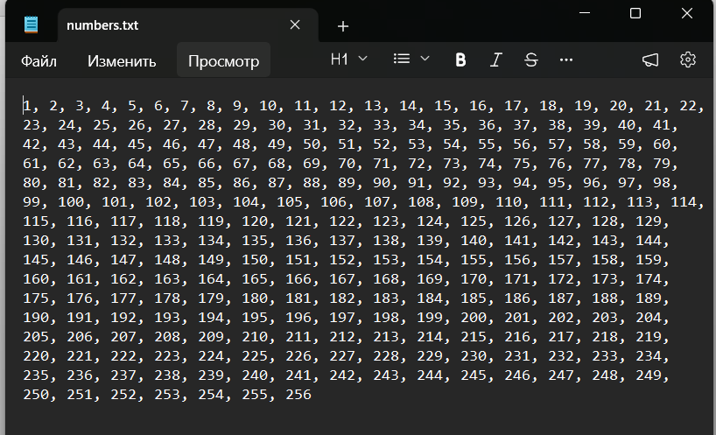
- lines = ["Toyota\n", "Ford\n", "Chevrolet\n", "Honda\n", "Nissan\n", "BMW\n", "Mercedes-Benz\n", "Audi\n", "Volkswagen\n", "Hyundai\n", "Kia\n"]
with open("numbers.txt", "w") as file:
File.writelines(lines)
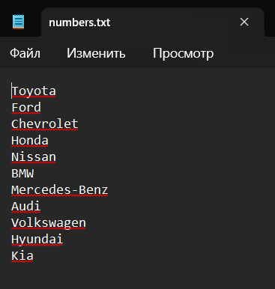
- max_len = 0
with open("numbers.txt", "r", encoding="utf-8") as file:
for line in file:
clean_line = line.rstrip("\n")
if len(clean_line) > max_len:
max_len = len(clean_line)
print(f"Длина самой длинной строки: {max_len}")
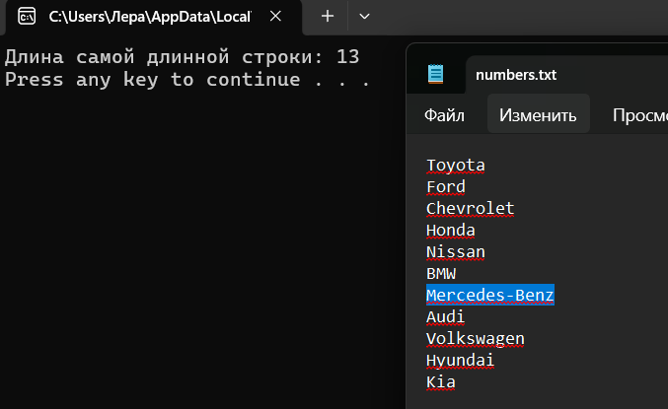
- print(f"Исходный массив: {arr}\n")
result_text = ""
print("Элементы с четными индексами:")
result_text += "Элементы с четными индексами:\n"
for i in range(0, N, 2):
print(f"Индекс {i}: {arr[i]}")
result_text += f"Индекс {i}: {arr[i]}\n"
print()
result_text += "\n"

print("Элементы с нечетными индексами:")
result_text += "Элементы с нечетными индексами:\n"
for i in range(1, N, 2):
print(f"Индекс {i}: {arr[i]}")
result_text += f"Индекс {i}: {arr[i]}\n"
with open("result.txt", "w", encoding="utf-8") as file:
file.write(result_text)


